ALL SAINTS CHURCH BOYNE HILL MAIDENHEAD
PARISH NEWS
www.allsaintsboynehill.org.uk
Issue 2 25 March 2020

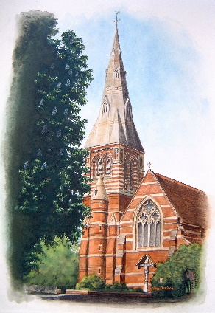

Index
To ease your way through this document, use the content topics below:
On a keyboard: Ctrl plus click
On a tablet or phone: touch document icon

All Saints Website

Worship for the Fifth Sunday of Lent 29 March

Pray for the Parish of All Saints

Reflection by Greg Hurst

All Saints Website
Please do use the All Saints website which has been populated with information, prayer resource and service recordings during this awful time whilst the is Church shut.
The site can be reached by clicking https://www.allsaintsboynehill.org.uk/
Many of the resources are now directly accessible from one-click links on the front page:-

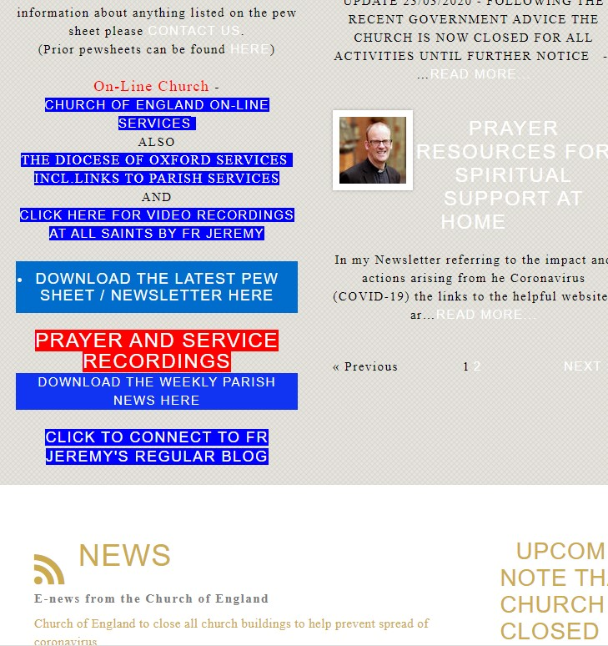

From here – on the LHS – you can directly link to:-

- The Church of England and the Diocese of Oxford on-line Church
- Video Recordings by Fr Jeremy in All Saints (Eucharist and Prayers)
- Prayer and service Audio recordings
- The weekly Parish News
- The Church of England newsfeed which will keep you up to date
- There is also a link to Fr Jeremy’s regular blog – please do keep in touch via this

From the menu at the top of the site you can link directly to a guidance page – which is also available from the “blog” section on the front page. A direct link to this page is https://www.allsaintsboynehill.org.uk/blogs/news/coronavirus-covid-19-guidance-and-update-fr-jeremy/

From the menu you can also go to the “welcome” page ( the direct link is https://www.allsaintsboynehill.org.uk/welcome-about-all-saints/welcome/ )

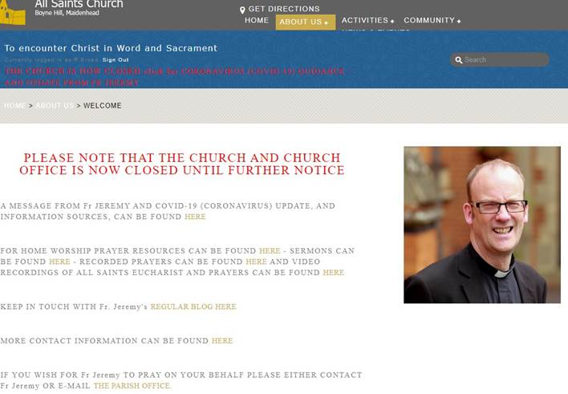

From this welcome page there are also one-click links to:-

- Information
- Worship and Prayer Resources
- Sermons
- Video Recordings
- Contact Information

And also a link to Fr Jeremy’s regular blog at https://frjeremysjourney.wordpress.com/ ,an example is:-

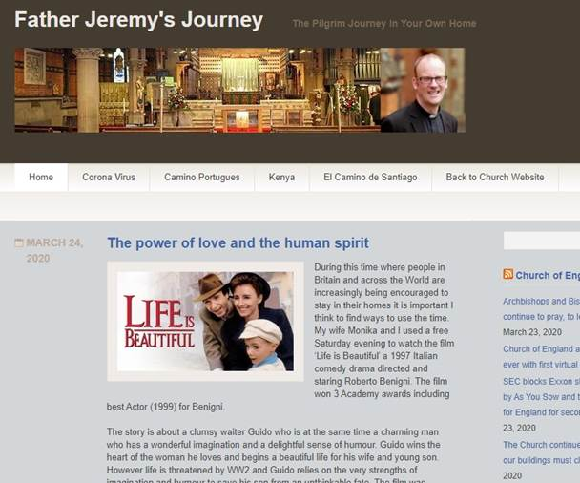

All Saints also has a facebook page with regular posts – please visit (and follow if you are able) at https://www.facebook.com/AllSaintsBoyneHill/

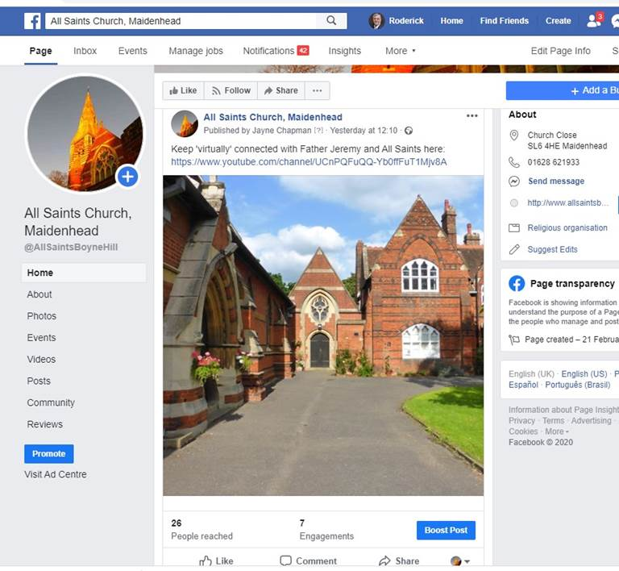

I hope that this gives you some idea of the easily accessible, and updated, information that is available.
The situation is changing rapidly and we will aim to keep the site up to date where possible – please visit as often as you can.
Thank you
Rod Broad

Pray for the Parish of All Saints
Attached to this newsletter is a list of all the roads in the parish. If you start with the first letter of your surname, over a period of days work forward so that all the roads are included.
You will possibly find some roads that you do not recognise. Why not take the time to Google and find our where they are?

Worship for the Fifth Sunday of Lent 29 March
Collect
Most merciful God, who by the death and resurrection of your Son Jesus Christ delivered and saved the world: grant that by faith in him who suffered on the cross we may triumph in the power of his victory; through Jesus Christ your Son our Lord, who is alive and reigns with you, in the unity of the Holy Spirit one God, now and for ever. Amen

John 11: 1 – 45
A certain man was ill, Lazarus of Bethany, the village of Mary and her sister Martha. Mary was the one who anointed the Lord with perfume and wiped his feet with her hair; her brother Lazarus was ill. So the sisters sent a message to Jesus, ‘Lord, he whom you love is ill.’ But when Jesus heard it, he said, ‘This illness does not lead to death; rather it is for God’s glory, so that the Son of God may be glorified through it.’
Accordingly, though Jesus loved Martha and her sister and Lazarus, after having heard that Lazarus was ill,
he stayed two days longer in the place where he was. Then after this he said to the disciples, ‘Let us go to Judea again.’ The disciples said to him, ‘Rabbi, the Jews were just now trying to stone you, and are you going there again?’ Jesus answered, ‘Are there not twelve hours of daylight? Those who walk during the day do not stumble because they see the light of this world. But those who walk at night stumble, because the light is not in them.’ After saying this, he told them, ‘Our friend Lazarus has fallen asleep, but I am going there to awaken him.’ The disciples said to him, ‘Lord, if he has fallen asleep, he will be all right.’
Jesus, however, had been speaking about his death, but they thought that he was referring merely to sleep.
Then Jesus told them plainly, ‘Lazarus is dead. For your sake I am glad I was not there, so that you may believe. But let us go to him.’ Thomas, who was called the Twin, said to his fellow-disciples, ‘Let us also go, that we may die with him.’ When Jesus arrived, he found that Lazarus had already been in the tomb four days. Now Bethany was near Jerusalem, some two miles away, and many of the Jews had come to Martha and Mary to console them about their brother. When Martha heard that Jesus was coming, she went and met him, while Mary stayed at home. Martha said to Jesus, ‘Lord, if you had been here, my brother would not have died. But even now I know that God will give you whatever you ask of him.’ Jesus said to her, ‘Your brother will rise again.’ Martha said to him, ‘I know that he will rise again in the resurrection on the last day.’ Jesus said to her, ‘I am the resurrection and the life. Those who believe in me, even though they die, will live, and everyone who lives and believes in me will never die. Do you believe this?’ She said to him,
‘Yes, Lord, I believe that you are the Messiah, the Son of God, the one coming into the world.’ When she had said this, she went back and called her sister Mary, and told her privately, ‘The Teacher is here and is calling for you.’ And when she heard it, she got up quickly and went to him. Now Jesus had not yet come to the village, but was still at the place where Martha had met him. The Jews who were with her in the house, consoling her, saw Mary get up quickly and go out. They followed her because they thought that she was going to the tomb to weep there. When Mary came where Jesus was and saw him, she knelt at his feet and said to him, ‘Lord, if you had been here, my brother would not have died.’ When Jesus saw her weeping,
and the Jews who came with her also weeping, he was greatly disturbed in spirit and deeply moved. He said, ‘Where have you laid him?’ They said to him, ‘Lord, come and see.’ Jesus began to weep. So the Jews said, ‘See how he loved him!’ But some of them said, ‘Could not he who opened the eyes of the blind man have kept this man from dying?’ Then Jesus, again greatly disturbed, came to the tomb. It was a cave, and a stone was lying against it. Jesus said, ‘Take away the stone.’ Martha, the sister of the dead man, said to him, ‘Lord, already there is a stench because he has been dead four days.’ Jesus said to her,
‘Did I not tell you that if you believed, you would see the glory of God?’ So they took away the stone.
And Jesus looked upwards and said, ‘Father, I thank you for having heard me. I knew that you always hear me, but I have said this for the sake of the crowd standing here, so that they may believe that you sent me.’
When he had said this, he cried with a loud voice, ‘Lazarus, come out!’ The dead man came out, his hands and feet bound with strips of cloth, and his face wrapped in a cloth. Jesus said to them, ‘Unbind him, and let him go.’ Many of the Jews therefore, who had come with Mary and had seen what Jesus did, believed in him.

Sermon
Text John 11:1-45 the Theme of the Cry for Help
In May 2000 I experienced a memorable 10 days pilgrimage in the Holy Land with my dear friend Fr Jeremy Winston and his parishioners of St Mary’s, Abergavenny. Fr Jeremy the gentle giant who encouraged so many young people during his ministry in Rogerstone, Newport (Where I first met him), St Arvan’s near Chepstow, Abergavenny before becoming The Dean of Monmouth in 20011. Sadly, he died not long after his appointment as the Dean and if truth be known many of us still miss his wonderful sense of humour and his incredible cooking skills as well as his sincere faith.
On Sunday 14th May, 2000 our pilgrim party walked the Way of the Cross on the Via Dolorosa. The way of sorrows begins at the Antonia Fortress, winding its way through the Old City and ending at the church of the Holy Sepulchre. After lunch we made our way to Bethany. Here we celebrated the Sunday Eucharist and recalled Jesus raising Lazarus from the dead. Having walked the stations reflecting on Jesus’ suffering I was invited to preach the resurrection at Bethany. Some challenge!
That day as I look back offers a link I believe to the themes today of The thirteenth station of ‘Walking the Way Of The Cross’ By Stephen Cottrell, Paula Gooder and Philip North, our chosen Lent book and the story of the raising of Lazarus.
Starting with Lazarus and using the creative material from ROOTS the resource for active Eucharistic worship I am inviting you at home to read the following words. ROOTS suggest you play ‘Lacrimosa’ from Mozart’s Requiem as you read.
Lazarus: ‘He did not come. I was dying. I think he knew this before the messenger arrived. He had a knack of knowing such things. So why didn’t he come? He was our friend, a constant visitor to our home. We loved him and we thought he loved us. At the onset of my last illness, Mary had sent him a message. We knew it would be difficult. He was miles away and had to come on foot. We knew, as well, that there was a price on his head. If he were discovered near Jerusalem, he would be arrested- and there was a watch over our home. Yet, we had never known him refuse a plea for help. And he had power. We’d witnessed some of his miracles. Blind men seeing, the lame walking, some with leprosy cleansed! We’d even heard of the dead being raised, but then again folk exaggerate, and the stories grow in the telling. So, we waited – impatiently, but expectantly. Surely, he would come. The messenger returned. I was growing very weak: Still no Jesus. The last thing I remember was seeing the fear, hurt and disappointment in my sisters’ eyes as they watched me slipping away. Then their piercing shrieks as I took my last breath. He had not come.’
Now we move to Stephen Cottrell’s reflection on the 13th Station ‘Why hath thou forsaken me?’ Possibly words that I have used more than any other at funerals. Cottrell asks, ‘Was this just another fiery preacher (Jesus) with all his big claims, just another lost soul screaming out to God in despair and battering his fists upon the locked door of heaven?’ And yet, ‘God is in this dying man, and in his dying man experiencing the horrors and the strife and all the fear and isolation, that is the daily currency of sin and death, for now I can even see myself in him. He is dying for me.’ Cottrell now concludes so hopefully ‘And in sharing this death and in the consequence of sin, ………..drawing the sting of it’s venom, all of it and for ever, all in loving it, it is defeated.’
St Paul puts it this way (1 Corinthians 15: 55-56) Where O death, is your victory? Where O death is your sting?
The questions asked by the Lazarus text and the suffering Christ coming among us as humans experiencing our suffering leads to the victory of the Cross and New Life. That day in Jerusalem and Bethany on pilgrimage allowed me to experience that hope. And to have confidence that our cry is answered.
In the name of the father, Son and Holy Spirit.
Footnote:
Another activity from ROOTS I have adapted for the present times and the COVID 19 crisis . There are many people asking questions like Lazarus and Jesus at this time. Write a short prayer yourself for a person suffering or distressed or for a community or indeed a country. Think about people who have lost loved ones, think about the NHS striving to look after us, think about our own fears. Reflect suggests ROOTS using REM’s ‘Everybody hurts’ or Allegri’s ‘Miserere’.
Pray in resurrection hope. Amen

Reflection by Greg Hurst
I never thought I would live through a lockdown. Like many people I have found the past couple of weeks surreal as restrictions on our daily lives tightened more and more.
Some of the reactions have been very disappointing.
Panic buying and hoarding by some – many, in fact – shoppers has been exasperating. We met an elderly women in our local shop. All she wanted was to buy a packet of Weetabix, she said. She surveyed the empty shelves, saw they were all gone, and began to cry.
It has been bizarre to see pictures of crowded trains, throngs of men on construction sites, groups gathering in sunny parks in defiance of instructions to keep a safe distance and stay at home unless really necessary.
Yet I have seen inspirational acts, too – so many volunteers supporting the NHS, neighbours looking out for one another, communities finding new ways to connect.
Before this month I had never used Zoom, the video conferencing app. This week we celebrated Mother’s Day with a virtual family party linking seven locations via Zoom, I had a Zoom choir practice and my mother had a Zoom book club discussion.
After two weeks confined at home, one of my biggest challenges has been to draw a line between the working day and evening and, especially, the working week and weekend without our normal weekend activities: none of our children’s clubs, no sports fixtures, no church.
We are all learning to live with this new normal. And we must count our blessings as we do so.

